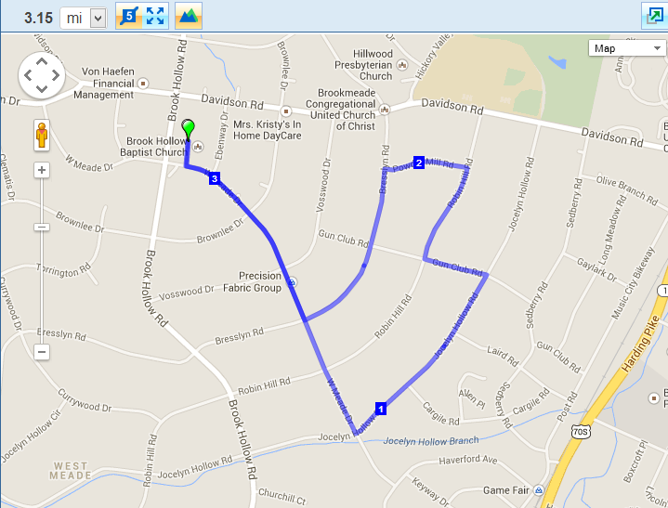

**Hill YEAH! 5K - West Meade**

